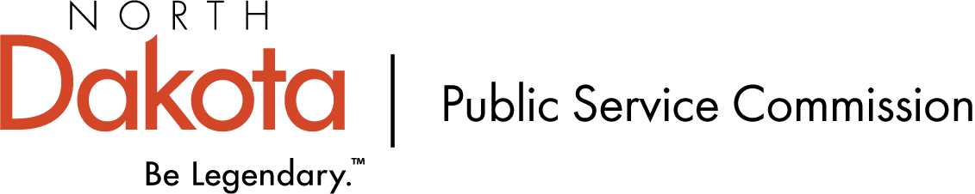
INVOICE

Billing Date: May 5, 2021

Invoice No. 160072
FROM:  ND Public Service Commission  600 E Boulevard Ave. Dept. 408  Bismarck, ND 58505-0480  Phone: 701-328-2400  Fax: 701-328-2410 |  | BILL TO:  Keith Larson  Daktel Communications, LLC  630 5th St N  Carrington, ND 58421
CASE NO. | CASE NAME
PU-21-41 | Daktel Communications LLC  Designated Eligible Carrier Expansion  Application
ACT CODE | EXPENSES INCURRED TO DATE:
621020 | Advertising Services |  | $474.60
 | Total Amount Due |  | $474.60
Please make all checks payable to:

North Dakota Public Service Commission

Federal Tax ID 45-0309764

