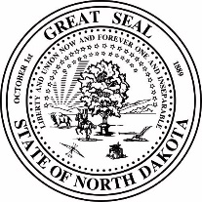 | Public Service Commission  State of North Dakota

COMMISSIONERS  Randy Christmann  Sherri Haugen-Hoffart  Julie Fedorchak | 600 East Boulevard Avenue Dept. 408  Bismarck, ND 58505-0480  Web: www.psc.nd.gov  Phone: 701-328-2400  ND Toll Free: 1-877-245-6685  Fax: 701-328-2410  TDD: 800-366-6888 or 711

April 20, 2023

Lynette Sweet
Xcel Energy
143 Eva Place
River Falls, WI 54022

Re: | Case No. PU-22-311  Northern States Power Company  2021 Power Purchase Agreement Costs  Compliance

Enclosed is a check in the amount of $9,863.46. This check is for an application fee final refund approved at the March 29, 2023, North Dakota Public Service Commission meeting.

This check represents a refund of the portion of the application fee paid in the above case, less expenditures. Attached is an accounting showing the original fee paid in the case, expenditures deducted, and amount remaining.

If you have any questions regarding the fee process, the refund, or the expenditures, please contact our office at (701)328-3397.

Best Regards,

Victor Schock, Director
Public Utilities Division

Enclosures

