sent via email and regular mail
January 29, 2024
Mr. Jeffrey Fleischman, Chief
Denver Field Division
Office of Surface Mining
PO Box 11018
150 East B Street
Casper, WY 82601-7032
jfleischman@osmre.gov

Dear Mr. Fleischman:
The Coteau Properties Company has filed an application for Revision No. 28 and Renewal No. 4 to Surface Coal Mining Permit NACT-0201 held by the Coteau Properties Company for the Freedom Mine. This revision updates various sections of the permit for the next 5-year permit term, and it proposes to mine leased federal coal in the E½ of Section 4, T145N, R88W and the E½ of Section 12, T144N, R89W, Mercer County. This federal coal is leased under NDM 91535. The next permit term is April 14, 2024 through April 14, 2029. The Office of Surface Mining must make the determination if this revision to mine new areas of leased federal coal constitutes a mine plan modification.

Enclosed is a flash drive containing the permit application for Revision No. 28. All updates to the permit are listed in Section 1.1.2 (Revision Summary Pages). Section 3.1.3 (Pit Layout and Facilities Map) has been updated to identify coal removal areas during the next permit term.

We would appreciate any comments on the revision application by March 14, 2024. If you have any questions, please contact this office.

Sincerely,
Jonathan Emmer
Director
Reclamation Division

Enclosure

cc via email only: John Sieving (jsieving@osmre.gov)

Freedom Mine\Permits\NACT - 0201\Revisions & Renewals\Rev 28 & Ren 4\Rev28_Advsry_rvw_rqst_ltr_1-29-24

sent via email and regular mail
January 29, 2024
Ms. Elizabeth Shaeffer
Field Operations Manager
P.O. Box 25065
Denver, CO 80225-0065
eshaeffer@osmre.gov

Dear Ms. Shaeffer:

The Coteau Properties Company has filed an application for Revision No. 28 and Renewal No. 4 to Surface Coal Mining Permit NACT-0201 held by the Coteau Properties Company for the Freedom Mine. This revision updates various sections of the permit for the next 5-year permit term, and it proposes to mine leased federal coal in the E½ of Section 4, T145N, R88W and the E½ of Section 12, T144N, R89W, Mercer County. This federal coal is leased under Lease NDM 91535. The next permit term is April 14, 2024 through April 14, 2029. The Office of Surface Mining must make the determination if this revision to mine new areas of leased federal coal constitutes a mine plan modification.

Enclosed is a flash drive containing the permit application for Revision No. 28. All updates to the permit are listed in Section 1.1.2 (Revision Summary Pages). Section 3.1.3 (Pit Layout and Facilities Map) has been updated to identify coal removal areas during the next permit term.

We would appreciate any comments on the revision application by March 14, 2024. If you have any questions, please contact this office.

Sincerely,
Jonathan Emmer
Director
Reclamation Division

Enclosure

Freedom Mine\Permits\NACT - 0201\Revisions & Renewals\Rev 28 & Ren 4\Rev28_Advsry_rvw_rqst_ltr_1-29-24

sent via email and regular mail
January 29, 2024

Josh Alexander
Bureau of Land Management
Billings Field Office
Eastern Montana Dakotas District Office
Department of Interior
5001 Southgate Dr.
Billings, MT 59101
jalexand@blm.gov

Dear Mr. Alexander:

The Coteau Properties Company has filed an application for Revision No. 28 and Renewal No. 4 to Surface Coal Mining Permit NACT-0201 held by the Coteau Properties Company for the Freedom Mine. This revision updates various sections of the permit for the next 5-year permit term, and it proposes to mine leased federal coal in the E½ of Section 4, T145N, R88W and the E½ of Section 12, T144N, R89W, Mercer County. This federal coal is leased under Lease NDM 91535. The next permit term is April 14, 2024 through April 14, 2029. The Office of Surface Mining must make the determination if this revision to mine new areas of leased federal coal constitutes a mine plan modification.

Enclosed is a flash drive containing the permit application for Revision No. 28. All updates to the permit are listed in Section 1.1.2 (Revision Summary Pages). Section 3.1.3 (Pit Layout and Facilities Map) has been updated to identify coal removal areas during the next permit term.

We would appreciate any comments on the revision application by March 14, 2024. If you have any questions, please contact this office.

Sincerely,
Jonathan Emmer
Director
Reclamation Division

Enclosure
Freedom Mine\Permits\NACT - 0201\Revisions & Renewals\Rev 28 & Ren 4\Rev28_Advsry_rvw_rqst_ltr_1-29-24

sent via email and regular mail
January 29, 2024

Mr. Edward Kraft
Field Office Manager
Bureau of Land Management
ND Field Office
99 23rd Avenue West, Suite A
Dickinson, ND 58601
ekraft@blm.gov

Dear Mr. Kraft:
The Coteau Properties Company has filed an application for Revision No. 28 and Renewal No. 4 to Surface Coal Mining Permit NACT-0201 held by the Coteau Properties Company for the Freedom Mine. This revision updates various sections of the permit for the next 5-year permit term, and it proposes to mine leased federal coal in the E½ of Section 4, T145N, R88W and the E½ of Section 12, T144N, R89W, Mercer County. This federal coal is leased under Lease NDM 91535. The next permit term is April 14, 2024 through April 14, 2029. The Office of Surface Mining must make the determination if this revision to mine new areas of leased federal coal constitutes a mine plan modification.

Enclosed is a flash drive containing the permit application for Revision No. 28. All updates to the permit are listed in Section 1.1.2 (Revision Summary Pages). Section 3.1.3 (Pit Layout and Facilities Map) has been updated to identify coal removal areas during the next permit term.

We would appreciate any comments on the revision application by March 14, 2024. If you have any questions, please contact this office.

Sincerely,
Jonathan Emmer
Director
Reclamation Division

Enclosure
Freedom Mine\Permits\NACT - 0201\Revisions & Renewals\Rev 28 & Ren 4\Rev28_Advsry_rvw_rqst_ltr_1-29-24

sent via email and regular mail
January 29, 2024

Mr. David Glatt, P.E.
Director
North Dakota Department of Environmental Quality
4201 Normandy Street
Bismarck, ND 58503-1324
dglatt@nd.gov

Dear Mr. Glatt:
Enclosed is a flash drive containing the permit application for Revision No. 28 and Renewal No. 4 to Surface Coal Mining Permit NACT-0201 held by the Coteau Properties Company for the Freedom Mine. This revision updates various sections of the permit for the next 5-year permit term. The Pit Layout and Facilities Map, Section 3.1.3, has been updated to identify the coal removal areas during the next permit term. Other relevant updates are provided in Section 2.3 (Ground Water Hydrology) and Section 3.3 (Surface Water Management), which include design plans for sediment ponds that are to be constructed in 2024. All updates to the permit with Revision No. 28 are listed in the Revision Summary Pages in Section 1.1.2.

Please review the revision application with regard to your agency’s areas of responsibility and technical expertise, and for compliance with NDAC 69-05.2-16-02. Please provide any revision application review comments by March 14, 2024 in accordance with NDAC 69-05.2-10-01(2).

If you have any questions, please contact this office.
Sincerely,
Jonathan Emmer
Director
Reclamation Division

Enclosure

Freedom Mine\Permits\NACT - 0201\Revisions & Renewals\Rev 28 & Ren 4\Rev28_Advsry_rvw_rqst_ltr_1-29-24

sent via email and regular mail
January 29, 2024

North Dakota Department of Water Resources
C/O Project Review
1200 Memorial Highway, Dept 770
Bismarck, ND 58504
dwrprojectreview@nd.gov

Dear Project Review Team:

Enclosed is a flash drive containing the permit application for Revision No. 28 and Renewal No. 4 to Surface Coal Mining Permit NACT-0201 held by the Coteau Properties Company for the Freedom Mine. This revision updates various sections of the permit for the next 5-year permit term. The Pit Layout and Facilities Map, Section 3.1.3, has been updated to identify the coal removal areas during the next permit term. Other relevant updates are provided in Section 2.3 (Ground Water Hydrology) and Section 3.3 (Surface Water Management), which include design plans for sediment ponds that are to be constructed in 2024. All updates to the permit with Revision No. 28 are listed in the Revision Summary Pages of Section 1.1.2.

Please review the revision application with regard to your agency’s areas of responsibility and technical expertise, and for compliance with NDAC 69-05.2-16-03. Please provide any revision application review comments by March 14, 2024 in accordance with NDAC 69-05.2-10-01(2).

If you have any questions, please contact this office.
Sincerely,
Jonathan Emmer
Director
Reclamation Division

Enclosure

Freedom Mine\Permits\NACT - 0201\Revisions & Renewals\Rev 28 & Ren 4\Rev28_Advsry_rvw_rqst_ltr_1-29-24

sent via email and regular mail
January 29, 2024

Mr. Jeb Williams, Director
North Dakota Game and Fish Department
100 North Bismarck Expressway
Bismarck, ND 58501-5095
jwilliam@nd.gov

Dear Mr. Williams:
Enclosed is a flash drive containing the permit application for Revision No. 28 and Renewal No. 4 to Surface Coal Mining Permit NACT-0201 held by the Coteau Properties Company for the Freedom Mine. This revision updates various sections of the permit for the next 5-year permit term. The Pit Layout and Facilities Map, Section 3.1.3, has been updated to identify the coal removal areas during the next permit term. Baseline fish and wildlife information is provided in Section 2.7 (Fish and Wildlife Resources). Section 2.7.3 (Mining Impacts) has been updated to provide an analysis of mining impacts to threatened and endangered species. Pre-mining Land Use and Vegetation information is provided in Section 2.4 and Post-Mining Land Use and Revegetation information is provided in Section 4.0. All updates to the permit with Revision No. 28 are listed in the Revision Summary Pages of Section 1.1.2. Figure 1 is provided to help you realize where Permit NACT-0201 is located.

Please review the revision application with regard to your agency’s areas of responsibility and technical expertise. Please provide any revision application review comments by March 14, 2024 in accordance with NDAC 69-05.2-10-01(2).
If you have any questions, please contact this office.

Sincerely,
Jonathan Emmer
Director
Reclamation Division

Enclosure

Freedom Mine\Permits\NACT - 0201\Revisions & Renewals\Rev 28 & Ren 4\Rev28_Advsry_rvw_rqst_ltr_1-29-24

Figure 1: Surface Coal Mining Permit NACT-0201, Revision 28, Renewal 4 coal removal.

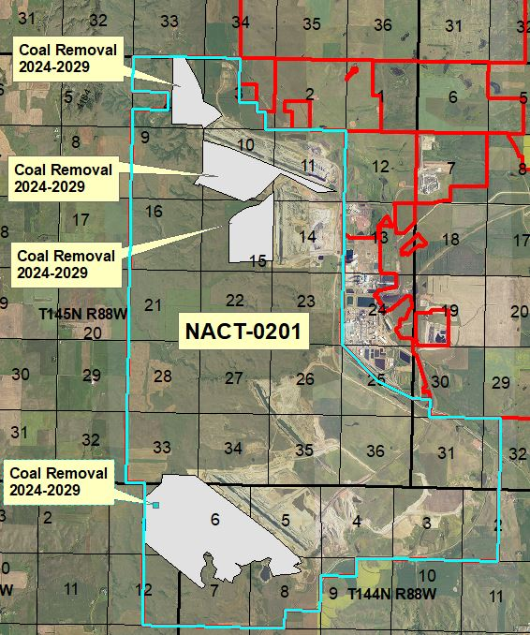
sent via email and regular mail
January 29, 2024

Mr. Luke Toso
U.S. Fish and Wildlife Service
3425 Miriam Avenue
Bismarck, ND 58501-7926
luke_toso@fws.gov

Dear Mr. Toso:
Enclosed is a flash drive containing the permit application for Revision No. 28 and Renewal No. 4 to Surface Coal Mining Permit NACT-0201 held by the Coteau Properties Company for the Freedom Mine. This revision updates various sections of the permit for the next 5-year permit term, and it proposes to mine leased federal coal in the E½ of Section 4, T145N, R88W and the E½ of Section 12, T144N, R89W, Mercer County. This federal coal is leased under NDM 91535. The next permit term is April 14, 2024 through April 14, 2029. The Office of Surface Mining must make the determination if this revision to mine new areas of leased federal coal constitutes a mine plan modification.

All Revision No. 28 updates to the permit are listed in Section 1.1.2 (Revision Summary Pages). The Pit Layout and Facilities Map, Section 3.1.3, has been updated to identify coal removal areas during the next permit term. Figure 1 is provided to help you realize where Permit NACT-0201 is located. Figure 2 and Figure 3 show the coal removal areas with greater detail on 2023 NAIP aerial imagery.

Baseline fish and wildlife information is provided in Section 2.7 (Fish and Wildlife Resources). Section 2.7.3 (Mining Impacts) has been updated to provide an analysis of mining impacts to threatened and endangered species. Pre-mining Land Use and Vegetation information is provided in Section 2.4 and Post-Mining Land Use and Revegetation information is provided in Section 4.0.

The USFWS Information for Planning and Consultation (IPaC) website indicates that four threatened or endangered species may exist in Permit NACT-0201. No proposed species or any designated or proposed critical habit within or immediately adjacent to the permit. The IPaC listed species include the Piping Plover, Rufa Red Knot, Whooping Crane, and Dakota Skipper. IPaC indicates that the Monarch Butterfly, a candidate species, may exist in the permit area. On page 4 of Section 2.7.3 (Mining Impacts), the Coteau Properties Company states that third party consultants are completing Dakota Skipper habitat assessment and occupancy surveys in accordance with the 2022 Dakota Skipper North Dakota Survey Protocol prior to mining disturbance. The Reclamation Division anticipates that it will find that the proposed operation will not affect the continued existence of endangered, threatened, or proposed species, or result in destruction or adverse modification of designated or proposed critical habitat.

We would appreciate any comments on the revision application by March 14, 2024. If you have any questions, please contact this office.
Sincerely,
Jonathan Emmer
Director
Reclamation Division

Enclosure

Freedom Mine\Permits\NACT - 0201\Revisions & Renewals\Rev 28 & Ren 4\Rev28_Advsry_rvw_rqst_ltr_1-29-24

Figure 1: Permit NACT-0201, Renewal No. 4, Revision 28 2024-2029 coal removal areas.

Figure 2: 2024-2029 coal removal areas in the northern end of Permit NACT-0201.

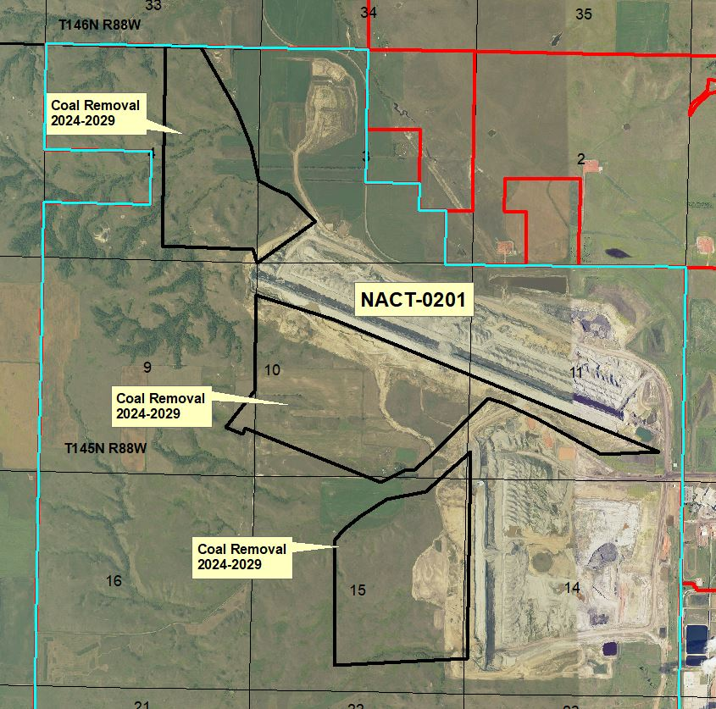

Figure 3: 2024-2029 coal removal areas in the southern end of Permit NACT-0201.

